Version <1.0>

Revision History

|  |  |  |  |
| --- | --- | --- | --- |
| **Date** | **Version** | **Description** | **Author** |
| <dd/mmm/yy> | <1.0> | <details> | Nguyen Kiem Hoa |
|  |  |  |  |
|  |  |  |  |
|  |  |  |  |

Table of Contents

1. Send Feedback 4

1.1 Brief Description 4

1.2 Actor 4

2. Flow of Events 4

2.1 Basic Flow 4

3. Special Requirements 4

4. Preconditions 4

5. Postconditions 4

6. Extension Points 4

# Send Feedback

## Brief Description

This use case defines the steps of sending feedback to developer. User can easily send developer to report some bugs , error, or some problem of software which they want to improve.

## Actor

User

# Flow of Events

## Basic Flow

When software is opening, click on tab “fb”. Then, user need fill in content box upper “Send feedback” button. After user send feedback, it will be store in database and developer can easily read it and improve the software.

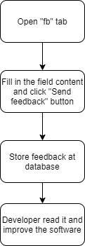

# Special Requirements

Not empty content box.

# Preconditions

No precondition.

# Postconditions

Feedback is stored at database.

# Extension Points

No extension point.